**LECTURE NOTES**

**ON**

**MANAGEMENT SCIENCE**

**UNIT – 1**

**INTRODUCTION TO MANAGEMENT**

**Introduction to Management:**

When human being started group activities for the attainment of same common objectives whenever a group is formed and a group activity is organize to achieve certain common objectives management is needed to direct, co-ordinate and integrate the individual activities of a group and secure team work to accomplish organizational objectives. The objectives of all business are attained by utilizing the scarce resources like men, materials, money etc.

**Definition:**

Different experts have expressed their views on what management is. The following explain the concept and nature of management.

According to F.W. TAYLOR ‘’ Management is the art of knowing what you want to do in the best and cheapest way ‘’.

According to KOONTZ AND O’DONELL “Management is defined as the creation and maintenance of an internal environment in an enterprise where individuals working together in groups, can perform efficiently and effectively towards the attainment of group goals”.

**Nature and Features of Management:**

The following describe the nature and features of management.

1. Management is a social process: - All business organizations are social organizations as they are constituted of men. The management has to control, org anise and motivate them. It can improve their levels and create a favorable climate for their development.

2. Management is goal - oriented: - Management aims to achieve economic and social objectives. It exists to achieve some definite goals. Group efforts in management are always directed towards the achievement of some pre-determined goals. It is concerned with the establishment and accomplishment of these objectives.

3. Management is a factor of production: - Management is not an end itself. It is a means to achieve the group objectives. Land, labour and capital are the important factors of production. They are essential for the production of goods and services. Management is also a factor of production. It is required to coordinate the other factors of production for the accomplishment of pre-determined goals. The 4 other factors may prove ineffective in the absence of management. Management occupies a central place among production factors.

4. Management is a distinct process: - ‘’ Management is a distinct process performed to determine and accomplish sated objectives by the use of human beings and other resources ‘’. It is different from the activities, techniques and procedures.

5. Management id needed at all levels of the organization: - According to the nature of work and the scope of authority, management is needed at all levels of the organization. It is needed at the top level, middle and supervisory level of the organization. Like the chief executive, the lowest level supervisor has also to perform the functions of decision - making.

6. Management is universal in character: - Management is required in all types of organizations. Wherever, there is some human activity, there is management. The basic principles of management are universal. They can be applied in all organizations. Whether they are business, social, religious, educational, political or military. Managers at all levels perform the same basic functions.

7. Management is a system of authority: - Management is a process of directing men at work to perform a task, authority to accomplish the work through others. Authority is the power to get the work done from others and it is very much essential as a person with responsibility and authority perform most efficiently so that he can accomplish the goals of the organization.

8. Management is a dynamic function: - Management is a dynamic function. It has to be performed continuously. It is constantly engaged in the molding of the enterprise in an ever changing business environment. In a real sense, it is a never ending function.

9. Management is an Art as well as a Science: - Management is a science because it has developed certain principles which are of universal application. But the results of management depend up on the personal skill of managers. In this sense management is an art. The art of the manager is essential to make use of the management science.

10. Management is a profession: - In the present day’s management is recognized as a profession. It has a systematic and specialized body of knowledge consisting of principles, techniques and laws. It can be taught as a separate subject.

11. Management is multi-disciplinary:- Management has to deal with human behavior under dynamic conditions. Therefore, it depends up on wide knowledge derived from several disciplines like engineering, sociology, psychology, economics, mathematics and anthropology.

12. Management is an intangible force: - Management is not an abstract thing. It is a social skill., which cannot be seen with the eyes. But the quality and the level of organization provide its evidence.

**Role and Importance of Management**

In the last two centuries, rapid industrial development has changed the face of the industrial economy. A new industrial culture has emerged out of the rapid industrial development. The development in science and technologies in production operations has made management more complex. The role and importance of management in today’s industrial society can be viewed by the following.

1. Helps in Achieving Group Goals: - Management assembles and organizes available sources for the accomplishment of the goals an enterprise. It adds effectiveness to the efforts of a group persons organized achieve given objectives.
2. Optimum Utilization of Resources: - Management utilizes available physical and human resources productively. It eliminates wastages in all business operations. Thus, it results in effective running of business activities.
3. Reduces Costs: - To secure efficiency operations, management is concerned with reducing costs of production and increasing the output. Through better planning, organizing and control and the use of various cost reduction techniques, efficient management leads reduced costs and increased output.
4. Establishes a Sound Organization: - Management lays down a pattern of authority-responsibility relationship. The structure so formed shows the various inter-related positions for which the right type of persons with right qualifications and training are selected.
5. Maintains Equilibrium: - Management helps in organization to survive in its dynamic environment. Good management enables an enterprise an enterprise to adjust to the complex and ever-changing external environment. Thus, management is responsible for survival and stable growth of an organization.
6. Essential for Prosperity of the Society: - Efficiency of the management leads to greater and more economical production for the society. Through increased welfare activities, it improves the standard of living of the people. Moreover, through its creative activities like designing new product and adopting new technology, management provides maximum satisfaction of consumer needs in society.
7. Effective Functioning of Business: - Some of the factors responsible for the effective functioning of business are ability, experience, mutual understanding, coordination, motivation and supervision. Management makes sure that the abilities of workers are properly used and cooperation is obtained with the help of mutual understanding.
8. Innovation: - New ideas are developed by the management and implemented in the organization. Better performance is achieved through new ideas.

**LEVELS OF MANAGEMENT**

An organization may have various levels of management. The term ‘level’ involves persons arranged in a series. Thus, levels of management suggest the arranged managerial positions in an organization. The number of levels of management in an organization depends upon its size, technology and the range of production. Broadly speaking, there are 2 levels of management. Viz., administrative management and the operative management. Administrative management concerned with ‘thinking’ function such as policy determination, planning and fixation of standards. Operative management on the other hand, is concerned with the ‘doing’ function which includes use of men, materials, machinery and money, implementation of policies laid down by administrative management and directing operations to achieve the objectives of the organization.

On the basis of functions, the levels of management can be shown in the following figures:

**Administrative Management Operative Management**

Performs thinking functions Performs doing function --- policy determination --- use of various factors of production --- planning production --- implementation of policies --- fixation of standards --- directing operations

The main significance of levels is that they determine authority relationships in an organization. On the basis of authority and responsibility levels of management can be classified into 3 categories. These are often termed as the management pyramid. This is shown in this figure.

**Levels of Management**

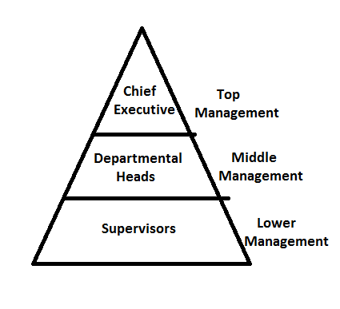

**Top management**: - The top management of an organization consists of the Board of Directors, a Chairman and a Chief Executive Officer. Top management integrates the functions of the whole organization.

**Functions of Board of Directors:**

* Act as trustees for the use of company’s properties.

* Determining basic objectives and policies.

* Select top executives and determine overall organization structure.

* Approve budgets and appropriation of corporate earnings

* Check and control top managers

* Perform legal functions covered under the Companies Act.

**Functions of Chief Executive**:

* Formulation of long-term plans and taking strategic decisions.

* Providing guidance and directions to various functionaries in the organization.

* Integrate the efforts made by various departmental heads.

* Perform staffing functions like appointing senior personnel, fixing pay structure, etc.

* Ensure that actual work is going on according to plans.

* Integrates the organization with the external environment to maintain relations with various agencies in society.

**Middle management**: - Middle management consisting of Functional heads such as Production manager, Financial controller, etc., and Divisional and Sectional officers working under functional heads. This is the level of management, which stands between the top management and the supervisory management.

**Functions of Middle management**:

* Performs various functions, so that top management gets enough time to integrate overall functions of the organizations.

* Ensuring cooperation among different levels of management.

* Train employees to function better.

* Contribute towards functions of other departments to achieve organizational goals.

* Integrates the various parts of a department in whose context management is taking action

**Supervisory or Lower-level management**: - Lower level management is also called operational level which includes foremen, supervisors and superintendents who are in direct touch with the rank and file of workers.

**Functions of Lower management**:

* To plan the activities of his section, classify and assign jobs to the workers.

* To manage and arrange necessary materials, tools etc, for the workers.

* To ensure proper maintenance of machineries etc.,

* To provide on-the-job training to the workers.

* To supervise and control the functions of the workers.

* To solve problems of workers relating to jobs.

* To communicate the problems of the workers which are not solved at his level.

* To provide feedback to management about the nature of work environment in his section.

* To maintain discipline among the workers, develop right type of approach in them and maintain good human relations.

At the supervisory level the functions are detailed and routine. The level is directly concerned with handling operatives.

-------------------------------------------------------------------------------------------------------------------------------

**FUNCTIONS OF MANAGEMENT**

Management is the process of getting things done through others and the person who does it is called a manager. He may be a director, an executive, a supervisor or a foreman. Management is a dynamic process consisting of several activities. These activities which every manager has to perform, are known as the functions of management.

The following are the different functions of management:

1. Planning
2. Organizing
3. Staffing
4. Directing (i) Leadership (ii) Communication (iii) Motivation
5. Coordinating
6. Controlling

**Management Functions**

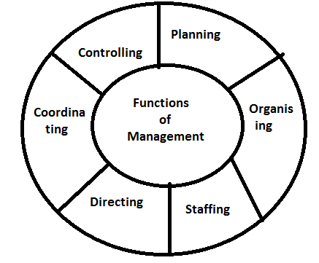

1. **Planning**: - Planning is nothing but determination of future course of action and it is the primary function of every manager. It touches every aspect of management. Planning is deciding in advance what is to be done, who is to do it and how results are to be evaluated. It consists of formulating the objectives, policies, program mes and progress. Planning requires forecasting of future situation leads to correct decision about future course of actions.
2. **Organizing:** - Organizing means the creation of a structure of functions and duties to be performed to achieve the goals of the enterprise. Organization also includes the authority and responsibility relationship for the efficient realization of objectives and development. The groups are to be well identified in organization for definition and delegation of authority.
3. **Staffing:** - It relates to the interrelation between different functions of job, department and personnel of enterprise. Staffing means the recruitment of enough quantity of personnel with required qualities for different positions in the organization. Right person should be selected for the right job. Staffing also includes selection and training functions of manager. It also includes the functions like promotions, demotions, indiscipline action, compensation etc.
4. **Directing**: - In this function of management the manager will guide, teach and supervise the sub-ordinates for the accomplishment of objectives. The function of directing includes :

(i) Leadership (ii) Communication (iii) Motivation

The main objectives of directing is

To get the work done

To see that the management work more responsibly

(i) Leadership: - It is the process of guiding and influencing the work of sub-ordinates for achieving the goals. Leadership is a function of every manager at every level in the organization.

(ii) Communication:- It is the process of passing information from one person to another person and getting feedback. The communication should be in 2 ways i.e., from superior to subordinate and subordinate to superior. A manager must develop an effective system of communication so that he can pass on orders, instructions and guidance to the subordinates and get the reactions of the subordinates.

(iii) Motivation:- Management can get desired result from the people by motivating them properly. Motivation is nothing but creating an environment where in the employee can work hard for the achievement of organizational goals. For that the management has to create enthusiasm in the minds of the employees. For this purpose management can use financial and non-financial incentives.

1. **Coordinating**:- Coordinating means building up a team spirit and unity of action among the subordinates to achieve common business objectives. In a business unit, hundreds of persons are busy in numerous jobs in various works in so many different places. So it is necessary managers must coordinate all the workers for achieving the organizational goals.
2. **Controlling:**- The controlling function involves those activities, which are essential to see that events are processed as planned. Controlling is laying down performance standards, measurements, interpretation and corrective action. Controlling consists of verifying where everything occurs in conformity with the plan, instructions and principles. The process of control involves three things:

* setting of standards for desired performance

* a comparison of actual performance against standards

* taking corrective actions

**Conclusion**: These functions are not conclusive. The word management is very dynamic and changing. It includes new problems; hence the management has to accept these changes. All the above described functions of management are interrelated. They are not independent and no one can function properly without involving the other. It is circular in nature. So there is no beginning or ending in the process. The only thing is that the relative emphasis on different functions changes according to situation.

----------------------------------------------------------------------------------------------------------------------------

**Management Vs Administration**

The terms ‘’ Management ‘’ and ‘’ Administration ‘’ are used interchangeably in business enterprises. Generally, all those who are responsible for the determination of objectives, and making decisions for their achievement are referred to as managers or management in business enterprises, and as administrators or administration in government organizations. Virtually they all perform the same functions of Planning, Organizing, Staffing, Directing, Coordinating and Controlling.

This is often a conflict between the two terms administration and management. Some authors say that administration and management is the same thing and there is no difference between the 2 words while others feel that they are different functions. These 2 terms represent 3 different approaches namely:

1. Administration is Above Management
2. Administration is part of Management
3. Administration and Management are one and the same
4. **Administration is Above Management**: According to many classical thinkers, administration is above management. They believe that the activities of both are different. The general view is that administration relates to implementation of policies. Administration determines the basic frame work off the organization with in which managerial functions are taken. According to them administration is related to higher level functions and management is related to lower level functions.

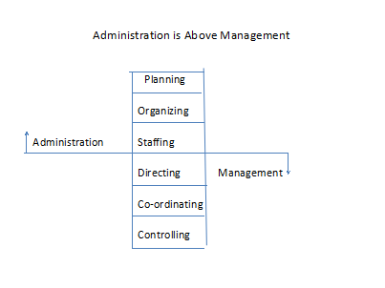

1. **Administration is a part of Management( or ) Below Management**:

This approach says that management is a comprehensive term and administration is a part of it. This view was supported by Brech. According to Brech, ‘’Management is the total process in the organization and the Administration is a part of management which is concerned with the implementation an carrying out the procedures laid down by the Management’’. If this approach is accepted, administration becomes subordinate function to overall management functions.

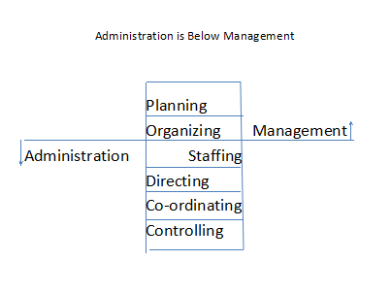

1. **Administration and Management are one**: According to third approach it is the most popular and practical one. This approach says that both involve the same functions, principles and objectives. There is no difference between the two terms and the difference whatever lies between them is mostly in their use in different fields of human activities. Administration is a

word used in government organizations and management is a word used in business organizations.

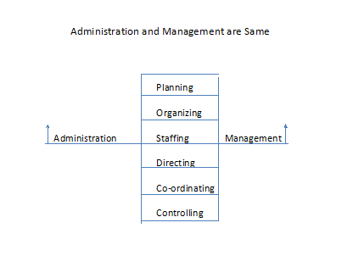

Above given approaches reveals that there is no separate staff to perform these functions. All managers, regardless of their level perform the same functions. The higher up in the hierarchy, however, the more time will be spent in administrative activity and the less in management activity in the manager’s daily routine, as shown in the diagram:

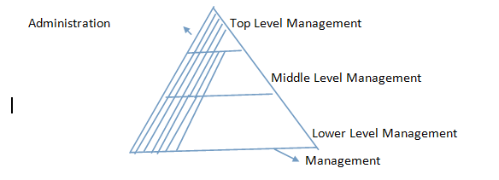

It is thus apparent that top management is predominantly concerned with the performance of administrative functions, whereas at the lower levels of hierarchy are predominantly occupie with executive functions. However, all managers perform administrative as well as management functions.

**The Evolution of Management Thought**

**Henry Fayol’s Principles of Management**

Henry Fayol a French industrialist developed a general theory of management in all aspects of business of an undertaking. Fayol defined managerial functions as forecasting and planning, organizing, commanding, coordinating and controlling. He identified six types of activities to be accomplished in every industrial organization:

1. Technical (e.g. Production)
2. Commercial (e.g. Buying and Selling)
3. Financial (e.g. Procuring capital)
4. Security (e.g. Protecting property and people)
5. Accounting (e.g. Maintaining account books)
6. Managerial (e.g. Planning, organization, command, coordination and control)

**Fayol identified 14 principles of management. They are:**

1. Division of work:- Division means dividing the works on the principle of specialization. The functions of management like planning, organizing, directing, coordinating cannot be performed by one group of directors. These functions are to be performed by the experts in the specific area.
2. Authority and Responsibility :- Authority and Responsibility should go together. An executive can do justice with his responsibility only when he has proper authority. Responsibility means accountability. Authority means right and power to act. Those who accept authority should be willing to share responsibility when a person is authorized to a job, he will be responsible for his performance. Everybody in the organizational structure must understand the limits of authority and responsibility.
3. Discipline:- Discipline is very important for the efficient functioning of enterprise. Discipline maintained among the officials and subordinates in all levels can guarantee the fulfillment of objectives of the management. Both the employer and employees should respect each other by observing the rules.
4. Unity of Command:- Unity of command means , employees should receive orders from only one superior. If the individuals are assigned work under more than one superior then performance and degree of the discipline will not be guaranteed, personnel will be confused, whom they should report.
5. Unity of Direction:- Unity of direction deals with the functioning of body corporate. There should be one common plan for one unity. Unity of direction means one unit, one plan whereas unity of command was defined as one person should have orders from one boss only.
6. Subordination of Individual Interest to General Interest:- Group interests or goals of organization must prevail any time over the individual interests or personal goals.
7. Remuneration:- Remuneration is the price paid to the employees for the services rendered by them to the enterprise. Remuneration should enable the employees to lead a satisfactory life and other special offers like shares or profits, festival bonus are paid to the employees. Remuneration should be given based on the living cost and capacity of the enterprise.
8. Centralization of Authority:- Centralization of authority means that the authority is in the hands of centre i.e., the authority will not be distributed among different sections.
9. Scalar chain:- Managers are a chain of superiors. There should be an unbroken line of authority and command from all levels to highest or lowest rank.

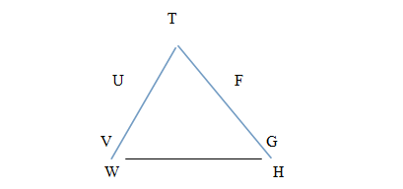

The diagram shows that T holds the authority on two departments. T will give orders to U and U will pass on to V and so on. T will also issue instruction to F, who will pass on these to G and so on. Now, if W wants to consult H, then W will approach to V and V to U, U to T so it will take long time, hence chain is necessary to make the communication fast and effective.

1. Order:- This promotes the idea of keeping the right man in the right job and right material at the right place.
2. Equity:- This implies that the dealings with the employees should be so fair and so open that they will reinforce their commitment to the organization. Be kind and fair to them.
3. Stability:- Stable and secure workforce is an asset to the firm, because unnecessary labour turnover is costly. It will indicate the avoiding of the frequent transfer of the employee before he settles down.
4. Initiative:- The staff should be encouraged to show initiative within the limits of authority and discipline.
5. Esprit De Corps:- This principle of management emphasizes the need for teamwork among the employees and shows the importance of communication in obtaining such teamwork. Strength, stability, stature and reputation depend on the relations among the personnel.

These principles reflect how the organizations should be structured. They also explain how the managers and workers should be taken care of. Henri Fayol contributed immensely to the growth of the professional management. Hence, he is hailed as the father of modern management.

**TAYLOR’S SCIENTIFIC MANAGEMENT THEORY**

F.W.Taylor is well known as the ‘’ Father of Scientific Management ‘’. Fredrick Winslow Taylor spent a lot of time for finding solutions to the problems on shop floors with an aim to increase the efficiency. Taylor noted in his observations that the tools and equipments used by the workers on shop floors were primitive in nature and the workers intentionally delayed the work. Taylor was able to support the workman and workers on the shop floor by giving solutions to the problems faced as he himself spent his life time on a shop floor as a worker and rose to the level of manager. Taylor developed and designed tools and equipments which could reduce the fatigue of the workers by using standardized equipments which led to increase in the efficiency and ultimately productivity of the shop.

Scientific Management is the process of application of scientific principles to systematic analyzes the work and to find solutions for all the problems associated with improving the efficiency of the methods of working.

**The elements of the principles of scientific management suggested by F.W.Taylor are as follows:**

1. Separation of Planning and Doing:- Taylor emphasizes the separation of planning aspect from actually doing the work. He said that planning should be left to the supervisor and the worker should emphasize only on operational work.
2. Functional foremen ship:- Taylor evolved the concept of functional foreman ship based on specialization of functions, which could improve the planning work sufficiently besides keeping supervision on workers.
3. Job Analysis:- Job analysis is undertaken to find out the best way of doing things with the least movements, using less time and cost. This is determined, by taking up time-motion-fatigue studies
4. Standardization:- Standardization should be maintained in respect of instruments and periods of work, working conditions etc.
5. Scientific selection and Training of workers:- Taylor has suggested that workers should be selected on scientific basis taking into account their education, work experience , aptitude, physical strength etc.
6. Financial Incentives:- According to Taylor, wages should be based on individual performance and not on the position which he occupied.
7. Economy:- Taylor suggested adequate consideration to be given to economy and profit.
8. Mental Revolution:- Mutual cooperation between management and workers can be achieved through mental change from conflict to cooperation in both parties.

**Criticism of Scientific Management:-**

The theory of scientific management was heavily criticized by the employers, the workers and psychologists. The employers criticized the process of scientific approach as costly and unworkable. Some of the other arguments against scientific management were:

* It ignores the functional areas of management such as marketing, finance and so on.

* Individual creativity is ignored by favoring one best way.

* Worker is reduced to a cog in the machine

* Mobility among workers gets restricted because of narrow specialization.

* Workers were not involved in the planning part of the job which was controlled by the management. As a result, some of the jobs created continued to be repetitive and boring.

Workers too, did not like to part with the rule of thumb privilege. They felt more insecure to adhere to the scientific standards given by management.

**Benefits from Scientific Management:-**

Scientific Management proved to be very beneficial to the industry at largee

* Scientific Management improved working methods and brought enormous increase in productivity.

* It developed a rational approach to measure tasks and processes with a considerable degree of accuracy.

* It initiated certain improvements in working methods, plant design and other things, based on information generated by measurement of tasks and processes.

* Piece rate wage system was introduced and incentive systems were evolved.

* It stimulated the employers and the higher levels of management to take a positive view of leadership at the shop floor operations.

* Physical working conditions for the employees underwent a sea change.

* It laid the foundation for work study and other related techniques.

* The scientific approach replaced the most widely prevalent traditional rule of thumb approach.

**MAYO’S HAWTHORNE EXPERIMENT**

Scientific management focused attention on the mechanical and physical aspects of organization functioning. These factors have given a positive result in increasing efficiency of the organization. Followers of this approach notably Taylor, Fayol, Gantt and others recognized the importance of human elements in the organization. But the emphasis was not appreciable. It leads to the human relations approach, the essence of human relations contributions are that the organizational situation should be viewed in social terms as well as in economic and technical forms.

Many researchers have been conducting studies in this field and first of its kind was conducted by Mayo’s research team ‘’ Hawthorne Experiments ‘’. These were carried out in Hawthorne plant of the General Electrical Company, Chicago which was manufacturing telephone system bells and employing about 30,000 workers at the time of experiments. This company was extending material benefits to workers, still its productivity was much below its expectations. There was also great dissatisfaction among workers.

The researchers originally set out to study the relationship between Productivity given and physical working conditions.

They conducted researches in four phases which are as below

* Illumination experiments to determine the effect of illumination on productivity

* Relay Assembly Test (RAT) room experiment to study the effects of changes in hours and other working conditions on productivity.

* Mass interviewing program me to determine workers attitude and sentiments.

* Bank wiring observation room experiments to determine and analyze the social organization at work.

It has created a new phenomenon in the world of management and this approach is known as ‘Human Relations Approach ‘. Hawthorne experiments suggested that good human relations involve motivating people of the organization in order to develop team spirit which effectively fulfill their needs and achieve organizational goals. The results of experiments which motivate people at work are given below:

1. Illumination Experiments:- These were undertaken to find out varying levels of illumination on productivity. The hypothesis was that, productivity would increase with higher illumination. So, for this purpose, a group of workers were selected and made to work in various intensities of illumination, but to the surprise of researchers they found that the productivity initially increased because the workers were happy to be involved in the experiment and that they gave the same output at any intensity of illumination and stopped the work when illumination was equal to the moon light. The conclusion was that the human factor determined the productivity.
2. Relay Assembly Test Room Experiments:- These experiments were conducted to find out where there was any relationship between job conditions and productivity. There was productivity improvement which was not due to the changes in physical factors like changing the incentive system, more rest time in between working hours, reduction of working hours and changes in working hours but that was due to change in attitude towards their work and work group. They developed a feeling of stability and sense of belongingness, responsibility and self-discipline.
3. Mass Interviewing Program me:- Under this programme about 20,000 workers were interviews in order to determine workers attitude towards the company, supervision, insurance plans, promotion and wages. But as the answers were over simplified by ‘Yes ‘or ‘No ‘response, the root of the problem was not identified. During the course of interview, it was discovered that workers behavior was being influenced by group behavior.
4. Bank Wiring Observation Room Experiments:- These experiments were carried out with a view to analyze the functioning of small groups and its impact on individual behavior. The work involved was to attach a wire to the switches if certain equipment used in telephone exchange. Hourly wage rate was fixed based on the output of each worker while the bonus was to be determined on the basis of average group output. The hypothesis was that, workers would produce more, to earn more and would others to earn more bonuses. The study revealed that informal relationship play on important role in determining the human behavior.

**MASLOW’S THEORY OF HUMAN NEEDS**

This is a motivation theory which is embarked upon the behavioral patterns of human beings. The behavior of an individual at a particular moment is determined by his strongest needs. The stage of needs is the outcome of priority of the individual. This only comes into dominance once the individual’s basic needs are satisfied. Maslow, a social scientist has given a step-wise growth and this is known as the hierarchy of needs.

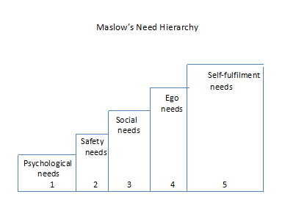

1. Psychological Needs:- This need will have the highest strength which includes the basic necessities of life like food, water, shelter and clothing. If one level of need is reasonably satisfied, then the individual looks for another need which is his next priority.
2. Security Needs:- Once the basic psychological needs are satisfied, then the individual tries to retain them and doesn’t want to lose them. This creates in him the need for safety and security. They include, safety against psychological dangers like fire, accident etc., and economic security against unemployment, old age, sickness, disability etc
3. Social Needs:- After the first two needs are satisfied, social needs like hierarchy becomes important. These are needed to associate with other people and be accepted by them to love and to be loved. Affection, friendship, association with family, friends and other groups of people, also fall part of social needs.
4. Esteem Needs:- These relate to the social status and prestige. A need for dominance also is a kind of esteem needs. They imply needs for independence, self-confidence, recognition and achievement etc.
5. Self-actualization Needs:- After all the four needs are attained and the person has the need to maximize his potential, so the individual works for his own satisfaction.

The above mentioned needs are arranged in a hierarchy of importance. Out of them, the psychological and safety needs are considered basic as they are to be satisfied first. A hungry person cannot concentrate on work as he thinks of and dreams of food till he gets it. Once those basic needs are satisfied, he desired fulfillment of the next level of dreams- social and esteem needs. This process continues from birth to death.

The above mentioned needs are not rigid. These needs may change in their intensity from person to person. Similarly, the level at which a person feels satisfied in respect to a particular need also may vary from person to person. Some individuals try to satisfy more than one type of need at a time and do not wait until he satisfies one.

The lower level of needs like psychological, safety and ego satisfying needs can be taken care of by providing them with a good salary, job security allowances etc. Opportunities for the fulfillment of higher level of needs can be provided in the form of praise, promotion, appreciation for good work, delegation participation in decision-making etc.

**Merits of the theory:-**

* The theory explains logically why different individuals behave in a different ways in a given situations. The theory also points out things that are common to all.

* Theory extends to all areas of a man life and is not combined to his work alone.

* Theory gives some insight in history and future trends. For instance, in the 19th century people or workers demanded enough waves to satisfy their psychological needs; in the early part of 20th century they started demanding for security and social needs. Therefore, there is no wonder that in future only higher levels needs alone can motivate people and dominate employee relations.

**Demerits of the theory:-**

* Human needs cannot be classified in to such a need and compact manner.

* The theory fails to explain the reason why some people try to satisfy more than one need at a time.

* It is not proper to classify needs into low order needs and high order needs, as the needs and they priority cannot be generalized.

* The importance also varies from person to person. The preference may also differ. For example, the need for self-esteem may be stronger than need for self-esteem may be stronger than need for self-esteem may be stronger than need for safety in case of some individuals.

-----------------------------------------------------------------------------------------------------------------------------

**MC-GREGOR’S THEORY X AND THEORY Y**

This theory was evolved at a stage when human behavior was considered as the prime factor for effective management. Motivation is an important tool which causes goal directed behaviour. Motivation brings a kind of psychological feeling that a human being applies himself to a creation work which gives him satisfaction i.e., goal directed behaviour leads to goal fulfillment, thus an individual succeeds in fulfilling his needs..

The management’s action of motivating the individuals in the organization involves certain assumptions, generalizations and deriving various hypothesis, which are related to the human behaviour. Mc Gregor’s theory is oriented upon the basic assumption that human behaviour may differ considerably because of various factors which are influencing and determining his behaviour. Mc Gregor has characterized these assumptions into two opposite view points. I.e., Theory X and Theory Y.

**Theory X:**- This is the traditional theory of human behaviour. The assumptions about the human behaviour are stated as negative in their approach. So based on these assumptions organizations and managers who believe in Theory X about human nature attempt to structure, control and closely supervise their employees. These managers feel that internal control is a must as the employees are irresponsible.

**Assumptions**:- *The personal are inherently lazy.

* They lack ambition.

* They require constant guidance and support.

* They are inherently self-centered.

* Their inherent nature is to resist change.

* They avoid responsibility, when an opportunity arises.

**Theory Y**:- The assumptions in theory Y are totally opposite to what we have seen in theory X. This theory emphasizes the need for a cooperative effort from management and employees. This theory highlights the requirement of today i.e., to get maximum output with minimum amount of input, control and direction.

**Assumptions**:- *T he expenditure of physical and mental effort in work is natural as play or rest.

* The average human being does not inherently dislike work. They feel work as a source of satisfaction.

* They exercise self-control and direction to meet the organizational goals.

* They take up responsibility.

* They exhibit a high degree of imagination, ingenuity and creativity in solving organizational problems.

* They face all types of challenges and are highly committed to the Organization.

In a society there are people of different traits. Some are of positive attitude and optimistic. They hope positive things will happen. While some are of negative attitude and pessimistic. They never hope for success. Generally people of negative attitude are taken as people of Theory X character, whereas people of positive attitude are taken as people of Theory Y character.

The general traits of Theory X people are,

*Laziness

*Less motivated

*Lack of initiation

*Dependent

*Avoids taking risks

*Never perform an activity on his own

*Relies on superiors or subordinates.

The general traits of Theory Y people are,

*Active

*Takes initiation

*Highly motivated

*Risk taking

*Goal-oriented

*Independent

*Good human relations

*Optimistic

*Empathetic

*Creator/Discoverer

-------------------------------------------------------------------------------------------------------------------

**HERZBERG’S TWO - FACTOR THEORY OF MOTIVATION**

This theory is also known as motivation-hygiene theory and was proposed by psychologist Fredrick Hertzberg. The basic principle behind this theory is the one’s attitude towards work determines the success for failure.

This theory was investigated by an experiment conducted on question, ‘’ what are goods and bads of their jobs?’ ‘’ from many accountants and engineers. The response were tabulated as satisfied or dissatisfied with their jobs. The goods about their jobs were achievement, advancement, recognition, autonomy and other intrinsic factors. The bads about their jobs were working conditions, salary, job security, company policy, supervisors and interpersonal relations.

The goods were termed as motivators and bads were termed as hygiene factors.

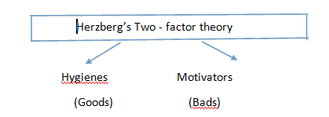

Hygiene factors:- According to Herzberg, the hygiene factors are the company policy and administration, interpersonal relationship with supervisors, peers, and subordinates, technical supervision, salary, personal life, working conditions and status.

Motivational factors:- The motivational factors are capable of having a positive effect on job satisfaction. The factors such as achievement, recognition, advancement, work itself, possibility of growth, job security and all other factors are related to work. An increase in these factors will satisfy the employees, once the employees are satisfied then they can be encouraged and motivated to achieve higher outputs.

According to two factor theory presence of motivator’s cause’s motivation in employees and their absence will not lead to job dissatisfaction. On the other hand, presence of hygiene factors will increase work but will not be able to increase satisfaction towards job and their absence will cause job dissatisfaction. Hence, motivation is necessary for self actualization and hygiene factors are needed to avoid pain.

**Merits:-** Herzberg’s theory is useful to the management as it explains and warn them that removes the causes for dissatisfaction, they can enhance employee motivation to any great extent. High and superior performance can be achieved only by providing positive measures. Management must, therefore improve the content of job to make them worthwhile, interesting and challenging. This can be achieved by

* Eliminating a layer of supervision

* Increasing autonomy and authority, i.e., to leave, when to do, how to do, when to rest, decide work etc., to the worker or employee

* Giving worker a complete unit of work. This will enhance his job satisfaction and individual pleasure.

* Giving the feedback directly to the worker without the involvement of supervisors or foreman

* Introducing new more difficult tasks not previously handled.

**Demerits:-**

* Herzberg’s motivators and de-motivators were nor clearly distinguished and clarified by him. They are not clear and definite.

* The theory also fails to explain why a same factors works as motivator for some and not as such to someone else.

* Moreover, the relative significance of these two factors may vary with time as the need satisfaction level of an employee is subject to frequent changes.

* The theory, which was based on the opinions of 200 people, gives scope for doubting its justification and dependability.

From the above analysis we can infer that Maslow’s approach is better and efficient and for a vast country like India, it is a better approach to follow. Because, India is a developing country with huge population over a billion, where basic needs are of more priority than the luxury needs as Maslow’s theory concentrated mostly on the necessary and basic needs it is better approach in India context point of view.

Comparison between the theories of Maslow and Herzberg:

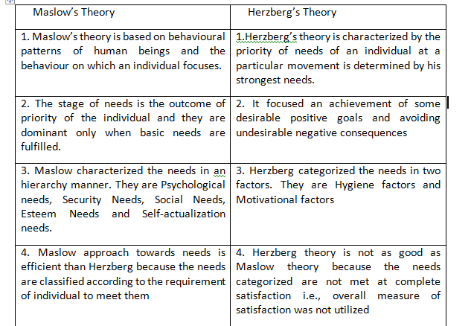

**System Approach to Management**

Modern approaches to understand management is the systems approach. Here the organization is viewed as a system. Every department is considered as a sub-system, it is also possible that every department can be viewed as a system and every section in the department can be viewed as a sub-system, system approach helps to study the basic feature and functions of the organization its minutest details. The collection of interrelated parts called as sub-system which constitutes one whole unit.

System approach facilitates the study of each of these parts in detail to have a close understanding of the whole system. **Ex**: Every part of the study such as the eyes, brain, and heart can also be viewed as a sub-system, a study of each of the parts of the body in necessary to understand the whole body

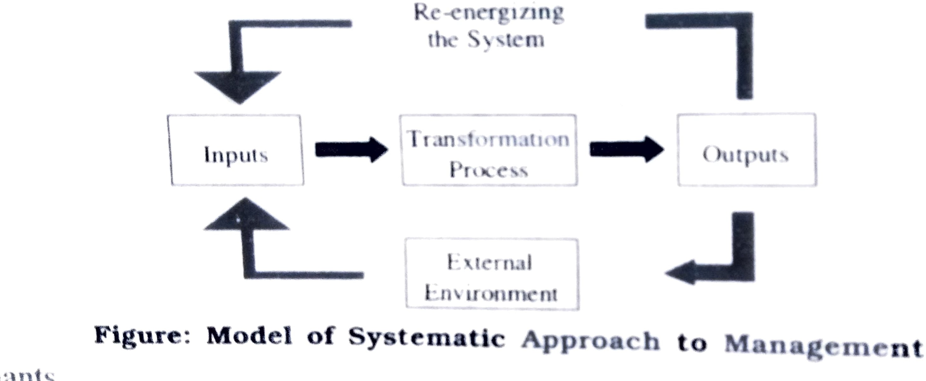

Elements of systems approach

1. Inputs and claimants
2. Transformation process
3. The communication system
4. External variables
5. Re-energising the system
6. INPUTS AND CLIMATS: The Enterprise receives inputs from the external environment consisting of Human beings, Capital, Income, Managerial skills and Technical skills. Other demands
7. Employees want benefits and security of their Job.
8. Consumers want Quality and Quantity of the at lower prices.
9. Suppliers want confidence that goodwill be bought intime and also wants to be safe.
10. Stock holders want higher returns on their investment and also security for their money.

These demands is the task of the managers to integrate them properly, specially with the objectives of the Organization.

1. TRANSFORMATION PROCESS: The main task of the Managers is to transform the inputs into outputs in effective manner.
2. THE COMMUNICATION SYSTEM: Communication is an essential function of the Managerial process for two reasons.

i)It integrates managerial functions.

ii)It links the Enterprise with external environment.

1. EXTERNAL VARIABLES: Managers will regularly check internal variables. Managers do not have the power to change the external environment.
2. RE-ENERGIGINH THE SYSTEM: In the system model some of the outputs become inputs again. For example: Profit are invested in Capital,
3. 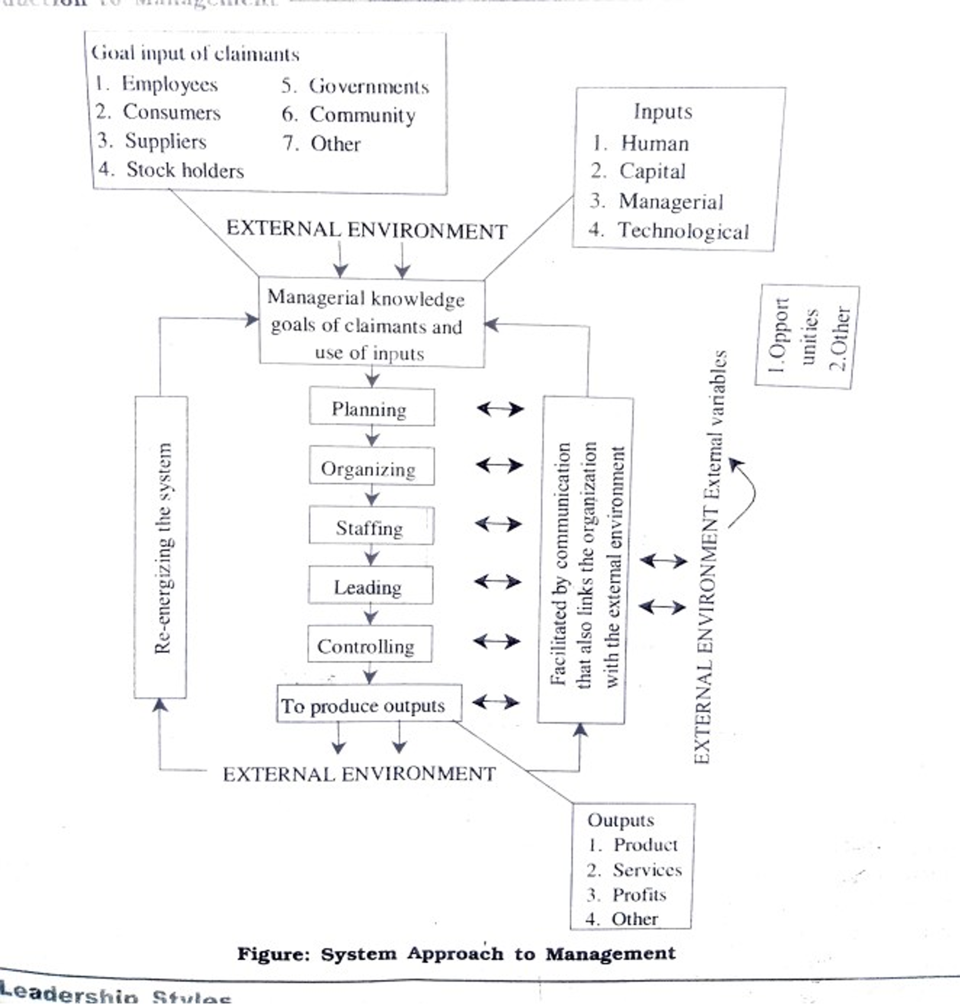

**ORGANIZATION DESIGN AND STRUCTURE**

* **Organization – introduction**:-

Organization is the foundation upon which the who structure of management is built it is the back bone of management without efficient organization no management can perform its functions smoothly.

Organization helps in planning staffing directing and controlling.

* **Meaning and definition of organization:-**

Organization is the system through which the resources of men materials .machinery and money about together in an orderly way to turn out finished goods at the minimum cost earning maximum profit. It can be defined as an” identifiable group of people contributing their efforts towards attainment of common goals”.

* According to koontz and O’Donnel organization mean “the establishment of authority relationship with provision for co-ordination between them both vertically in the enterprise structure”.
* The term organization is used by different authors in different senses (concepts). Broadly there are three senses in which the term organization is used:

1. Organization as a group

2. Organization as a structure

3. Organization as a process

1. Organization as a Group:-

It is a concept in which the organization is considered to be a group of people who are bonded together to perform various activities to achieve a concern goal.

2. Organization as a structure:-

According to this concept organization is a structure which defines the relationship among individuals and positions in the organization it is instrumental in fixing the duties and responsibilities of departments and individuals .the structure also facilitates workflow in the organization. The organizational structure looks like a pyramid with a narrow top and a broad bottom.

Organization structure of a manufacturing firm

Managing director

Production marketing finance

Manager manager manager

Factory stores sales advertising chief auditor internal manager manager manager accountant

Manager

Foreman Foreman store sales sales section section

Keeper supervisor supervisor officer accounts officerbills

3. Organization as a process:-

This concept tries to establish the organization of determining, arranging, grouping and assigning activities in order to achieve common objectives .Organization may be defined as the process of

i) Identifying and grouping the work to be performed.

ii) Defining and delegating the responsibility and authority.

iii) Establishing relationships for the purpose of enable people to work most effectively together in accomplishing objectives.

----------------------------------------------------------------------------------------------------------------------------

* **Management and organization**:-

Two or more people who work together in a structure way to achieve a specific goal or set of goals is called an organization management is the process of planning, organizing, leading and controlling the war of an organization and of using all the available resources to reach the specified organizational goal.

All organizations have people who are responsible for helping them to achieve their goals. These people are called ‘managers’. The success of an organization mainly depends upon the management strategies it employees without effective management organizations are likes to fail. Effectively manage money, man, machinery and material result in the success of an organization.

**Nature or characteristic of organization**:-

The following are the characteristic of organization.

* Large size:-Modern organizations employ hundreds and thousands of employees organizations in the past were generally small in size. Large organizations are a direct consequence of technical change and this in turn leads to economies of scale.
* Complexity:- Organizations involve huge investment, complicated technology and as their operations are spread over various continents their successful running has become quite a complex affair so elaborate rules and regulations are necessary for their governance.
* Common purpose or objectives:-Every organization exists to achieve some common objectives or goals. The structure of organization must reflect these objectives as enterprise activities are derived from them. It is bound by common purpose.
* Division of work:- The total work of the organization is divided into functions and sub functions. This is necessary to avoid the waste of time, energy and resources. Which arises when people have to constantly change from one work to another. It also provides benefits of specialization.
* Authority structure:-There is an arrangement of positions into graded series. The authority of every position is defined. It is one below it this chain of superior-subordinate relationship is known as chain of command.
* Communication:-Every organization has its own channels of communication. Such channels are necessary for mutual understanding and co-operation among the members of an organization.
* Coordination:-The divisional head coordinates the work of Different divisions depending upon the requirement of the organization only through coordination; harmious functioning of an organization becomes possible.
* continuing system :-Organization can continue to survive if it is able to adapt itself to its environment. It does not matter who joins or eave the organization.
* Pattern of behavior :-Policies, procedures, rules, regulations and proceed provide guidelines to behavior they enable the workers to maintain continuity, consistency and uniformity in their behavior.
* Differentiation :-In an organization work or divided systematically on the basis of the nature of the particular category of work among people recruited to handle the work thus. Task specialization leads to differentiation.

------------------------------------------------------------------------------------------------

* **Need for designing an organization** :-Organization is necessary for the following purposes
* Firstly, to identify and classify the required activities.
* Secondly, to group the activities necessary to attain objectives.

|  |
| --- |
|  |

* Thirdly to provide coordination horizontally and vertically in the organizational structure. Organization is very important for the success an enterprise. It helps the enterprise in the following ways.
* It increases the managerial efficiency, as organization defines various activities and their authority relationships.
* Organization provides strong mechanisms as it arranges various activities with a view to avidly and duplication of work.
* Specialization leads to optimal utilization of human effort.
* Organization facilitates effective communication and coordination.
* Organization facilitates growth and diversification
* It paves the way for creativity which gives rise to optimum use of technological innovations.
* Organization develops managerial abilities.

--------------------------------------------------------------------------------------------------------------------------

* **Formal And Informal Organization**:-

The organization structure designed and established by management id called formal organization is officially set up to achieve certain goals. It is a system of clearly defined activities and relationship which are intend to divide and integrate the activities of the organization .In this type of organization the description of organizational relationships is in written and graphic from. The participants are asked to do certain things in a specified manner to obey orders and to work cooperative.

Informal organization is described as a network of personal and social relations not stashed or required by the formal organization but arising spontaneously as people associate with an another the informal organization, it cannot be separated an organization is neither totally formal nor totally informal. It is a combination of the two aspects

.

**Distinguish between Formal and Informal Organization**

|  |  |
| --- | --- |
| Formal Organization | Informal Organization |
| 1.**Formation**:-Deliberately planned and  created by management. Interaction among people. | 1. Emerges spontaneously as a result of social Interaction among people. |
| 2.**purpose**:-To achieve planned fulfill  Organizational goals. | 2.To satisfy social and cultural needs and Common interests |
| 3. **Degree of rigidity /flexibility**:-more rigid | 3.More flexible |
| 4.**Structure:**-Has a well defined structure of tasks and relationships. | 4. Does not have a clear-cut structure but forms a complex network of reliability. |
| 5. **Behavior of members**:-Standards of behavior and performance are prescribed and enforced by management. | 5. Standards of behavior and performance are evolved by mutual consent among members. |
| 6. **Communication**:-formally establishes. | 6.Informal communication based on convenience. |
| 7. **Size**:-These are large size. | 7. These are small in size |
| 8. **Authority**:-Authority flows top to bottom | 8. Authority flows from bottom to top |
| 9. Focus is on job | 9. Focus is on role. |

* **Principles of organization**:-

Organization is the establishment of relationship among various persons and positions in the organization. It also involves the assignment of responsibility and delegation of authority for carrying out the assigned task efficiently and systematically. If the work is not allocated properly there may arise confusion and friction among people .If may not be possible to estimate all together the causes of conflict and confusion but a scientifically designed organization structure helps in reducing such chances.

Principles of organization have been enunciated by many early writers including Fredrick Taylor, Henry Taylor, Lynd all Urwick and others. They have been refined to serve as principles of organization and are outlined as follows

1.Principle of Objective:-

An organization structure is when facilitate the achievement of objectives. Therefore the organization as a whole and every part of it must be greeted to the basic objectives of the enterprise.

2.Principles of Specialization:-

The every individual should be assigned a duty according to his skill and qualification. The person should continue the same work so that he specializes in his work. This helps in increasing production in the concern.

3.Principle of Co-ordination:-

The co-ordination of different activities is an important principle of the organization. The organization structure should facilitate unity of effort and co-ordination among different individuals and grades channels of communication should be open an clear.

4.Principle of /authority and Responsibility:-

The authority flows down words in the line. Every individual is given authority to get the work down though authority can be delegated but responsibilities with the man who has been given the work. The responsibility cannot be delegated under circumstances.

6. Span of control:-

Span of control means how many subordinates can supervised by a supervised every manager should have a limited number of subordinates representing him directly. Generally the span should be narrow for complex work and wide for simple and routine work. Span should be neither for wide nor for narrow.

7.Principles of Balance:-

The principle means that assignment of work should be such that every person should be given only the much work which he can perform well. If some person is over worked and the other is under-worked. The will suffer in both the situations. The work should be divided in such a way that everybody should be able to give his maximum.

8.Principles of /continuity:-

The organization should be amendable according to the changing situations. Every day there are changes in methods of production and marketing systems. The organization should be dynamic and not static there should always be a possibility of making necessary adjustments.

9.Principle of Uniformity:-

The organization should provide for the distribution of work in such a manner that the uniformity is maintained. Each officer should be in charge of his respective area so as to avoid dual subordination and conflict.

10.Principle of unity of command:-

There should be a unity of command in the organization. Each subordinate should have only one superior whose command he has to obey. Every on should have only one boss. This is necessary to ensure discipline and to fix responsibility for results.

11.Principle of Exception:-

This principle states that top management should interfere only when something goes wrong. If the things are done as per plans then there is no need for the interference of top management. It is only the exceptional situations when attention of top management is drawn.

12.Principle of simplicity:-

The organizational structure should be simple so that it is easily understood by each and every person. The authority, responsibility and position of every person should be made clear so that the is no confusion about these things.

13.Principle of Efficiency:-

The organization should be able to cost achieve enterprise objectives at a minimum cost. It should permit the optimum use of resources. The organization should also enable the attainment of job satisfaction to various employees.

14.Scalar principle:-

This principle refers to the vertical placement of supervisors starting from top and going to the lower level. Every subordinate should know who his superior is and who is a subordinate are.

The above principles are guideless for planning an efficient organization structure.

**Organization structure/chart:-**

Organizational structure is of paramount importance for the success of any work, let alone, an enterprise. If prescribed the relationships among various positions and activities in business. Since various positions are held by persons so structure creates relationship among them

.**Features of a Good organization Structure**:-

A good organization structure should meet various needs and requirements of the enterprise. The following are the features of a good organization structure.

* Clear line of authority:-

There should be a clear line of authority from top to the bottom. Everybody in the organization should be clear about his work and the authority delegated to him. In the absence of this clarity there will be confusion, friction and conflict.

* Adequate delegation of authority:-

Delegation of authority must be commensurate with the responsibility assigned. If the authority is not sufficient for getting the assigned task them the work will not be completed.

* Less managerial levels:-

As for as possible minimum levels of management may be created more the number of these levels, more the delays in communication. It will take more time to convey the decisions from the top to the bottom. Similarly information from lower levels will take much time in reaching at that.

* Span of control:-Span of control refers to the number of people a manager can directly supervise. A person should supervise only that number of subordinates to whom he can directly keep under

Contact the universally fixed because it will be influenced by the nature of work.

* Simple and flexible:-

Organizational structure should be very simple there should not be unnecessary levels of management. A good structure should avoid ambiguity and confusion. The system should also be flexible to adjust according to changing needs.

* **Importance:***-*
* Organization chart shows the interrelationship an relative position of each deportment of the company.
* It shows the relationship between the lines of command i.e. authority and responsibility.
* It pin points the responsible for a particular function.
* It describes the weakness of the organization.
* It serves as a training device and as guide in planning for expansion.
* It is useful in showing the nature of the organization and changes in the existing in and the new-comers.
* The information available in this chart supplements the details available in the organizational manner.
* It clearly shows if any particular function is omitted.
* It shows the kind of managerial relationship which exists in the organization i.e. line, line and staff or functional.

**Types of organization**

One of the important components of organization process is the certain of suitable organizational structure. Organizational structure refers to the hierarchy of various positions in the organization. Organizational structure defines the various relationships between various positions, departments and individuals. It help in allocation of authority and responsibility and decides who is to report to whom.

The type of organization structure differs from plant to plant becomes of the type of industries or plant. The various types of organizations are

1. Line organization
2. Functional Organization
3. Line and staff Organization
4. Committee Organization
5. Product Organization.

**1.Line organization**:-

It is one of the oldest types of organizations. It was also known as the “military type of organization in the past. In this organization authority flows for top level to bottom level. Heads of the departments are given full freedom to control their departments. A senior member has direct command over his subordinates. Each member knows to whom he is responsible for the accomplishment of objectives of the organization.

**Line organization**

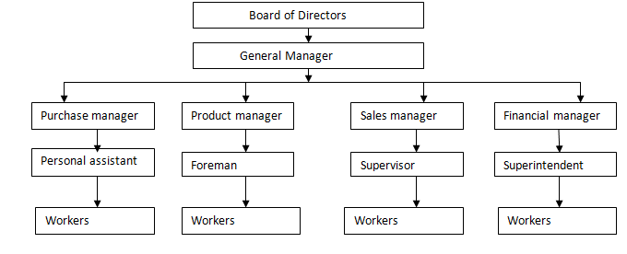

* **Features**:-
* It is a simple type of organization.
* Only one from of authority, viz, line authority exists in this form of organization line authority refers to the direct authority of a manager over his subordinates.
* The authority relationships are clearly establish authority to decide things and to act with respect to their respective functions.
* In a line organization departments are created for basic activities each of which is self-contained
* as the related services are also part of the activities of the departmental head.
* Specialized supportive activities are not specification recognized and distinguished in a line organization.
* **Advantages:**-

The main advantages of line organization are follows

1. Simplicity:-

Line organization is very simple to establish and can be easily understand by the employees.

2. Identification of Authority and Responsibility:-

It helps in fixing authority and responsibility of each and every person in the organization.

3. Coordination:-The hierarchy in management helps in achieving effective coordination.

4. Effective communication:-

There will be a direct link between superior and his subordinate both can communicate properly among themselves.

5.Economical:-Line organization is easy to operate and less expensive.

6. Quick Decision:-

Only one person is in charge of one division this enables managers to take quick decisions.

7. Utility of Command:- In line organization every person is under the command of one boss only.

8. Effective control and supervision:-

Direct link and less number of subordinates manage the manager to exercise effective control and supervision over the persons under him.

9. Executive Development:-

Manager task in challenging and he has to take many decisions. This helps him to learn many things and develop his capabilities.

10. Flexibility:-Manager can take a decision according to the requirements of the situation.

* **Limitations**:-

The system has the following drawbacks.

1. Excess work:-In line organization too much is expected from executives their workload goes on increase with expansion of unit.

2. Lack of Specialization:-Line officers cannot be experts in every line of business.

3. Lack of Co-ordination:-Each deportment head try to run the deportment in own way. This leads to no co-ordination among all the deportments.

4. Improper Communication:-Line officer may become autocratic and start deciding things without consulting his sub-ordinates. This will bring dissatisfaction among sub-ordinate and they do not convey their reactions of the workers to the superiors.

5. Lack of Initiative:-

Top management takes the decisions and the lower level managers do not show initiation to suggest any thing they think that top management may not consider their suggestions.

6. Favoritism:-There is scope for favoritism in line organization.

7. Instability:-The business depends on few people. Their disappearance from scene may create instability in the organization.

* **Applications**:-
* Automatic and continuous process industries.
* Small firm where complexities will be less.

--------------------------------------------------------------------------------------------------------------------------

2**. Functional organization**:-

F.W. Taylor suggested this type of organization to overcome the difficulties associated with middle level management in the line organization. It is similar to that of a line organization with a difference that instead of one supervisor or foreman there are eight functional specialists. Four of them located in

the shop floor and four as office specialists. Taylor’s functional organization suggests that everyone has direct and equal authority over the workers.

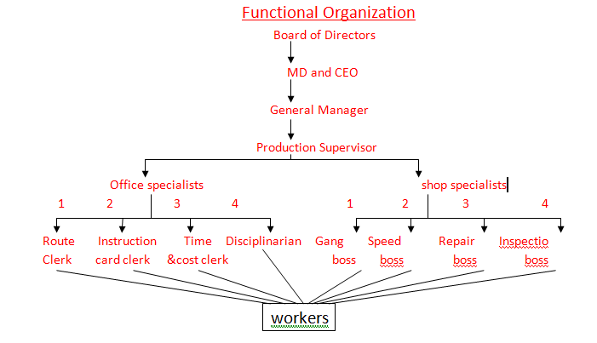

* **Office specialists**:-

In modern terminology those are concerned with planning(Route clerk),scheduling industrial engineering (Instruction clerk),time office and wage cell(Time and cost clerk)and personal department(Disciplinarian) fall under the category of office specialists.

* Route clerk:-He is responsible for planning route there which material will pass from machine to machine on the shop floor.
* Instruction clerk:-He is responsible for giving instruction and the process to be adopted in

production of components ,the methods and measures to be taken.

* Time and cost clerk:-He always down the start time for completion of a particular task and them he records the actual time taken completions.
* Disciplinarian:-He ensures the implementation of rules and regulations formulated enterprise in terms of work and general behavior to maintain discipline in the organization.
* **Shop specialist**:-In modern terminology those concerned with production (Gang boss), engineering (speed boss), maintenance (Repair boss) and quality control (Inspection boss) fall under the category of shop specialists.
* Gang Boss:-He is responsible for arranging the machine and tools required for production. He ensures adequate work for the workers and sees that necessary tools are available to the workers to complete the work in time.
* Speed Boss:-He determines the speed at which work should be processed. He ensures that the work is completed in the standard time .He decides on the optimum speed at which the work should be done.
* Repair Boss:-He will look into the preventive maintenance, breakdown maintenance, predictive maintenance of all machines. So that production does not suffer due to faulty machines.
* Inspection Boss:-He ensures that the work is do according to the specifications of materials used an the products manufactured, so use a whole inspection boss is responsible for maintaining the total product quality.
* **Advantages:-**

Functional organization has the following advantages

1) Specialization Improves Efficiency:-Specialist’s managers perform the work this type of organizations. If ensures specialization and every in doing one things.

2) Scope for Growth:- The functional organization provides wide scope for growth and mass production.

3) Flexibility:-Functional organization allows changes in organization according to the requirement without disturbing who work.

4) Relief to top Executives:-Delegation of authority makes the managers free for small works.

5) Economy of operations:-The use of specialist helps in cost reduction by counting all wastages.

6) Better supervisions:-The superiors being experts in work they will be in the position to get the things done by sub-ordinate efficiency.

7) Democratic control:-This type of organization eliminates one man control. It does not hamper organization growth because each man grows in his own specially.

* **Limitations**:-

Some of the drawbacks of the functional organization are

1. Conflict in authority:-The principle of ‘Unity of command’ is violated in functional organization.

2. Lack of co-ordination:- Co-ordination is several specialists in the organization it is very difficult to achieve co-ordination among them.

3.Difficulty in fixing responsibility:-Many people are involved in completing a task and everybody tries to blame others for low performances.

4).Delay in taking Decisions:- More than one person involvement in decision making leads to delay in taking decisions.

5).Poor Discipline:-Unity of command is not maintained, it creates problem of discipline.

6).Expensive:- This type of organization is more expensive because a large number of experts are appointed.

**3. Line and staff organization:-**

Both line and staff organization suffers from some drawbacks. Line organization is autocratic in nature and staff organization does not have a strong control. To eliminate the drawbacks of both the organization. The line and staff organization was evolved. It simplifies the relationships.

Line authority gives the supervisor a better chance to monitor and control the subordinates. As a matter of fact the exactness of a decision will depend on the responsibility and authority given to a decision makes. In the line and staff organization this has been provided. Whereas the line function in relations is advisory. To support the line function in terms as data material, personnel relations, labour welfare and all those facilities required for the production activity is the role of staff function in this organization.

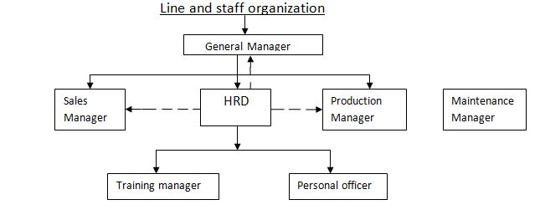

We observe the above chart the human resource development (HRD) as a staff function. Which extends it support to sales manager and production manager by any of recruiting training and development of employees and looking after the welfare unrest and taking problems connected to labor’s unrest and implementing personal policies to motivate employees to complete the targets.

* **Features of Line and Staff Organization:-**

The following are the some of the main features of line and staff organization.

* It is a modification of the line and functional organization .It’s more complex than the latter.
* There are two firms of authority-Line authority and Staff authority.
* Certain secondary and supportive activities which are related to the basic activities, are separated and formed into separate units or departments.
* There is more specialization and division of labour.
* Line managers get advisory and supportive assistant and services from experts in the staff departments.
* Line and staff organization is characterized by conflicts among managers because of difference in nature of their authority, influence, expertise and remuneration.
* **Advantages:**-

The advantages of line and staff organization are:

1. Specialization:-Line and staff organization introduces specialization in systematic manner.

2. Better Discipline:-The staff personal does not interfere with executive work of line officers. The workers get command from line personal, /unity of command is maintained and creates better discipline.

3. Growth and Expansion:-This structure is aquatic suitable to growth and expansion.

4. Development of Employees:-Separation of planning and doing functions provided more opportunities to the employees.

5. Lesser Burden on Line officers and Quick Actions:-

It adds the specialist to the line thus reliving the line manager of the subsidiary takes of thinking and enabling them to concentrate on the main job of producing & selling and take quick decisions.

* **Limitations**:-

The drawbacks of this type of organization are:

1. Conflict Between Line and Staff Personnel:-The line and staff relationship often lead to friction and jealousy. There is possibility of conflict between Line and staff organization.

2. Lack of Responsibility:-There is no responsibility to staff officials in line and staff organization structure.

3. More Dependence on staff:-Line managers are likely to tend to depend too much on staff experts and thus lose much of their judgment and initiative.

4. Lack of Co-ordination:-Overlapping of functions will create confusion and among employees.

5. In effective Staff:-There is the danger of the staff experts remaining ineffective because they do not have the authority implement the recommendations.

6. Expensive:-This type of organization is more expensive becomes a large number of specialists are appointed. To make the system of line and staff organization effective, The provision for various committees at all levels has to be made. This type of organization is used only in medium and large concerns.

* **Line and Staff Conflicts**:-

Line and staff relationship is based on the assumption that both support each other and work harmoniously to achieve organizational objectives. However, there are frequent instances of conflict between line and staff in the organization.

The various factors leading to line-Staff conflict can be grouped in to three categories.

1. View Point of Line
2. View point of Staff
3. Nature of the line-staff relationship.

**1. View point of Line Managers:-**

Line managers who are responsible for the final results leading to the achievement of the organizational objectives. Feel that staff people work again them in the following ways

🡪Lack of Responsibility:-

Line managers feels that staff people do not carry many responsibilities in the organization, but enjoy authority. Thus they do not care about the ultimate objectives of the organization.

🡪Theoretical Bias:-

Advice and recommendation of staff people lack practical implication. They tend to think within the context of their own specialty and use the Critter prescribed in their own discipline.

🡪Encroachment of Line Authority:-

Line managers feels that staff people encroach upon their authority. They give recommendations and advice on the matters which fall with in their jurise action. This is unnecessary interference with the working of their deportment.

🡪Dilution of Authority:-

Line people feel that staff people dilute line authority .Line managers may feel that their responsibility with be reduced because of the addition of staff, thereby making their job less challenging and varied. This feeling of insecurity makes line managers suspicious of staff managers which work against harmonious relationship between them.

**2. View Point of Staff Managers**:-

🡪Lack of Proper use of Staff:- Staff people feels that line managers do not make proper use of staff people. Staff people are ignored the decisions are made without.

🡪Resistance of New ideas:- Line managers often resist new ideas new ideas mean that there is something wrong with the present way of working. So many of the efforts of staff people go waste.

🡪Lack of proper Authority:-Staff people feel that line managers do not give enough authority to

them. They contribute to the realization of organizational objective without really enjoyingany authority.

**3.Nature of Line and Staff Relationship**:-

🡪Difference Backgrounds:-

Line and staff people often have different backgrounds and individual characteristics. Staff people in contact to line are generally younger better educated more poised in social interaction, more articulate and individualistic. As a result they often look down on the less educated line people. Who must have worked their way up through the organization. These differences create an atmosphere of mistrust and hatred between them.

🡪Lack of Demarcation between Line and staff:-

Through In theory the line and staff authority clear, often in practice demarcation between line and staff define description and relationships between them are not clarified. In such cases there is possibility for overlap can aggravate personal relationships.

🡪Lack of proper understanding of Authority:-

Even if line and staff authority is made clear in the organization, people may fail to understand the exact nature of line, staff and functional authority in practice. This may be a source of conflict.

* Solution to the conflict between line officers and staff officers

1. Both line officers and staff officers should clear understand the nature of relationship prevailing between them.
2. Line officers should be encouraged to use the advice of staff officers.
3. Staff officers should be convinced by the line officers if their advice is not accepted.
4. Only qualified persons should be selected and placed as staff officers.
5. The responsibility for results could be fixed on both line and staff officers.
6. Some line officers may resist the change, then it is the duty of staff officers to encourage the line officers to participate in the proposed scheme to change.
7. Only experienced persons alone should be promoted as line executives.
8. The staff officers can give full credit to the line officers for the results obtained.
9. If the favorable results are obtained, the staff officers may be appreciated by the line officers.
10. A special privilege may be given to the line officers to reject or accept the advice given by the staff officers.

**Distinction between Line, Line and Staff Functional Organization**.

S.no Feature Line Organization Line and staff Organization Functional Organization

1 simplicity high not so high low

2 suitability for small Enterprises for medium and for large enterprises

large enterprises

3 specialization low moderate high

4 work load of high moderate uneven

Manager

5 unity of strictly observed from not observe

Command observed great extent in general

6 economy high moderate low

------------------------------------------------------------------------------------------------------------------------------------------

**4.Matrix Organization**:-

Matrix organization is a combination of Functional organization and Project organization. when one organization has to handle a variety of projects ranging from small to large. It permits better planning, flexibility and service. The project structure provides a horizontal authority flow to the vertical authority flow of the functional organization of the project. Such persons have two bosses. One from the functional department and second the concerned project.

Matrix organizational structure is useful in various industries such as electronics, banking, advertising, software etc.,

**Matrix Organization**

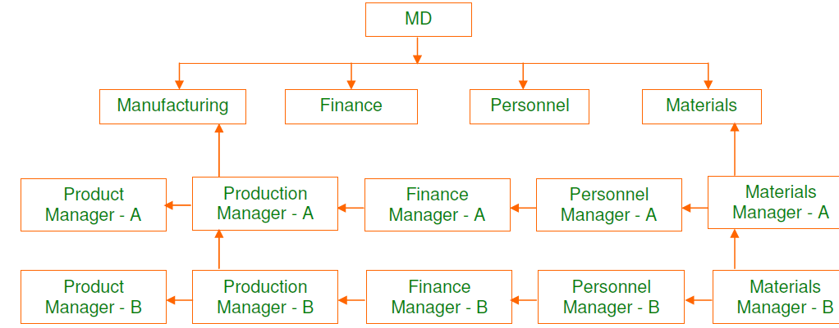

* **Advantages**:-

1. Efficient and effective utilization of existing available resources.
2. It is more flexible than a traditional functional organization.
3. It presents operational convince and operational flexibility.
4. It emphasizes multiple interdependence among various functions.
5. Its features make it more adoptable to crisis and change.
6. It utilizes the benefits of specialized expertise and capabilities’ of functional departments.

* **Disadvantages**:-

1. Matrix organization violates the principles of unity of command as a person works under two bosses to give rise to conflicts in the organization.
2. It is difficult to define authority and responsibility in this structure.
3. Organization relationships are more complex and the created problems of coordination.
4. Since persons are drawn temporarily from different departments, project manager does not have line authority ever them.
5. Project group is heterogeneous and due to which morale of personnel may be low.

---------------------------------------------------------------------------------------------------------

**5. Committee Organization**:-

A committee is a group of people, usually same authoritative level, which work collecting, discuss, decide and recommend solutions to the problems assigned to them. It consists of a group of people conversant with a subject. Naturally their advice will be much superior to that of one manager. Multifaceted problems too big and too complex to be dealt effect by one executive. The number of persons in a committee depends upon the need. Objectives responsibilities and authority of the committee should be clearly defined.

Committees may various types, depends upon need, intensity and urgency of the subject matter will decide the nature of the committee. committee may be: A standing or permanent committee, temporary committee. Co-ordination committee, advisory committee. The permanent committees are policy making and decision making bodies such as executive committees. The purchase committees, finance committees, maintenance committees, promotion committees etc, when an adhoc(Temporary) committee is formed to find appropriate solutions when specific problems arise.

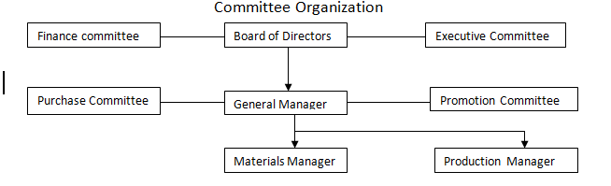

* **Advantages:-**

1. In this type of organization the information flow abilities and expertise of all the people involved. Can be integrated to set-up most effective objectives plans and policies.
2. There is democratic decision making and it reduces the chance of conflict.
3. Committee organization improves the interpersonal relationships. This is almost for better management.
4. As it will be a combined decision making it increases the commitment to implement those decisions.
5. In this type of organization dealing with complex problems becomes simplified as everyone contribute in problem solving.

* **Disadvantages:**-

1. Responsibility for decisions cannot be fixed one particular person.
2. It calls for high degree of co-ordination.
3. It involves high cost in terms of time and money.

The decision taken sometimes may not be the best as it is democratic type.

**6. Product Organization**:-

Grouping activities on the basis of product or product lines is known as product organization. It is usually done in large-scale enterprises. It permit top management to delegate extensive authority to a division of executives over the manufacturing sales, service and engineering functions that reduce to a given product or product line and to exact considerable degree of profit responsibility from experts of these managers

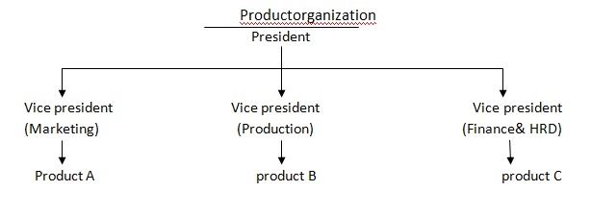

* **Advantages**:-

1. It strengthens the manufacturing facilities product wise or process-wise.
2. It provides for growth and diversification.
3. It ensures better customer care.
4. All facilities are available under one roof.
5. Responsibility can be fixed for sales and profits for each product or service.
6. Managers can be trained for senior positions.

* **Disadvantages**:-

1. Adequate number of qualified and professional managers may not be available.
2. Maintaining central services may not be cost of effective.
3. It tends to increase the problems of control for top management.
4. The organization may get disintegrated with increasing focus on departments.

Q**. What are the difference types of teams in an organization**?

Terms are special form of task group that have become increasingly popular. Generally a team is a group of members, that work together for the achievement of common tasks or goals of the organizations. In earlier forms the teams included autonomous work groups and quality circles. Today teams are most routinely used by firms to carry out their daily operations. These teams are often called “self managed teams”, “Cross functional teams” or “High performance teams”.

An organization can have any number of teams based on its requirements. Different types of teams are:

1. Problem-solving team:-

This is a team of knowledgeable workers that work collecting for solving a specific problem and then break up. It is most popular type of team.

2. Management team:-The management team consists of the managers as members. Here the managers can be different types such as human resources, sales, promotion, operational etc. It often co-ordination work among other team.

3. Work team:- The work teams are self managed teams responsible for perform the daily work. It is an increasing population to of the organization.

4. Virtual team:- In this team the members may not interact direct but interact though a computer. Members enter and leave the network as needed and may take turns serving as leader.

5. Quality circle team:-This team consists of members that discusses the work place problems .It is

often losing its popularity.

Q. **How is informal organization relevant to managers, in what ways; can managers make most effective use of informal organization?**

* **Informal organization**:-

Informal organization refers to the relationship between people in the organization based on personal attitudes, emotions, prejudices, likes, dislikes etc. These relations are not developed according to produces and regulations laid down in the formal organization structure. Generally large formal growth give rise to small informal or social groups. These groups may be based on some taste, language, rule or any other factor. These groups are not pre planned. They develop automatically in the organizations. Informal Organizations are small groups. It is an unofficial and social pattern to human interactions.

* **Managers Relationship to the Informal organization**:-

The goals objectives and methods of operation of a informal organization are desired to benefit its members. As the informal group can perform most positive and constructive tasks for its members the managers should permit the group to perform these tasks. The informal organization is very help to formal manager in regulating worker behavior communications.

So ,the function of manager is to combined the efforts and tasks of informal organization that of formal organization in to one single function .The informal and formal systems can work together if,

1. The employees have high belief in their manager that he takes care of their needs, respect their decisions. This type of belief is only exhibited by workers, when the manager’s actions are fair and are favorable to the worker. Here positive leadership styles such as ‘free-rein’ leadership can help a manager to obtain belief of workers.
2. The goals and objectives of formal organization are accepted by the employees. Hence there will be a support for achievement of goals.
3. The workers are given with some importance to achieve formal objectives. This will improve the belief and confidence of workers to the organization
4. Information is provided to the employees regarding policies that interest them.

* **Ways in which managers make most Effective use a Informal Organization**:-

A manager is a person who serves the organization to achieve organizational objectives and co-ordinate the resources of the organizations such as money, material, machinery and men. Generally the role of manager is crucial in any organization. A manager should reflect his subordinates.

A manager achieves the primary objectives of a organization i.e, high productivity and high morale by following the below guidelines.

1. Creating a positive work environment, so that his subordinates work n a way of achieving the predetermined goals of organization.
2. Implementing and respecting the decision of his subordinates in order to gain their confidence.
3. He recognizing the significance of co-ordination him. His subordinates and creating a friendly environment, so as to get work done.
4. Frequently appraising the performance of his subordinates and rewarding them (for their Merit).

**Boundary less Organization**

A boundary less organization is a combination of team and network structure with frequent changes and temporariness. The internal boundaries between systems and external boundaries between external environments are removed. Forming a boundary less system.

The boundary less organization structure is formed to produce quality products so as to give better services to the customers by easy and free communication amongst company, dealer and customer. This is done by linking cross functional people from various parts of an organization through computers, faxes, CAD systems, video telecom fermenting, etc and utilizes them as and when required. The development of outsourcing and networking throughout the world has rapidly increase productivity and flexibility of an organization.

The best thing about this structure is that it eliminates chain of command and over span by replacing the departments with empowered teams. Elimination of vertical and horizontal boundaries and breaking of external barriers between company and customers has resulted in increased business levels.

The boundary less organization uses technology CII hence is also known as T-form organization (or) technology based organization.

* **Merits:-**

1. The inefficiencies between company and customer are reduced by using it.

2. Higher flexibility, quality, speed, creativity, etc are some of the benefits of boundary less organization

* **Demerits:-**

1. The organization is temporary and changes frequently.

2. Problems in communication will make the organization in effective.

SOCIAL RESPONSIBILITIES TO MANAGEMENT

**Social Responsibility**: Social responsibility refers to the process with includes

several activities from providing safe products and services to giving apportion of

the company’s profits to welfare organizations.

Responsibility towards shareholders: The business enterprise has the responsibility to provide fair return on capital to the shareholders. The firm must provide them regular, accurate, and full information about the working of enterprise in order to fulfill and encourage their interest in the affairs of the company.

Responsibility towards consumers: The management has to provide quality products and services to the customers at reasonable prices. It should consider

customer suggestions and also plan it services more effectively through consumer satisfaction survey.

Responsibility towards employees: Good working conditions motivate workers to

contribute their best it is the responsibility of the management recognize their

unions and respect their right to associate with a union of their choices.

Responsibility towards creditors: The business has to repay the loans it has taken from the financial institutions as per the repayment schedule also it should inform the creditors about the developments in the company form time-to-time.

Responsibility towards Government: The business firm has to pay its taxes and

be fair in its endeavours. It should also support the government in community

development projects.

Responsibility towards competitors: The business firm should always maintain

the highest ethical standards and maintain cordial relations with each of the competitors, which is a critical and sensitive segment.

Responsibility towards public: Business units have tremendous responsibility

towards the general public to support the cause of community development.

Most of the companies maintain public relations departments exclusively to

maintain good relations with the community.